Spring Boot Crud Application

Figure 1 Intelij print screen regarding the FTL files used to our web application 2

Figure 2 Intelij print screen of the main/java folder regarding the MVC structure used to our web application 2

Figure 3 Login Form in order to access the site 3

Figure 4 Login Form error message for unauthorized user information 3

Figure 5 Logout page(delete the cookies of the user/admin sessions) 4

Figure 6 User login Redirect Page for e.g. (username , password) = (ssore1@gmpg.org , pass1234) 4

Figure 7 The main(index) page regarding the Admin web interface application. In order to login as an admin use the following credentials: (username , password) = (lrutgers3@ustream.tv, pass1234) 5

Figure 8 The 3 Search pages : Afm, email, surname regarding the 5th record/user of our database 5

Figure 9 The 3 Search pages Redirection site regarding the 5th record/user of our database where 3 different methods invoke upon the same result page (/search1, /search2, /search3) 6

Figure 10 The 3 Search pages Redirection site regarding false input or generally no matched entry 6

Figure 23 Search Repairs functionality regarding the database entries of 2018-12-17 6

Figure 11 Contributors Page (About Option) 7

Figure 12 Contributors Page Functionality according to each image (onclick event) 7

Figure 13 Owner Page of Admin’s web interface application 8

Figure 14 Repair Page of Admin’s web interface application 8

Figure 15 Create new entry for the Owner Page of Admin’s web interface application 9

Figure 16 Display Owners page i.e. display all the values of the Owners table from the database 9

Figure 17 Owner’s Update option regarding the 1st entry ( the id is unable to be altered ) 10

Figure 18 Owner’s Delete option functionality regarding the 20th entry 10

Figure 19 Create new entry for the Repair Page of Admin’s web interface application 11

Figure 20 Display Repair page i.e. display all the values of the Repair’s table from the database (except for the password) 11

Figure 21 Repair’s Update option regarding the 12th entry ( the id is unable to be altered ) 12

Figure 22 Repair’s Delete option functionality regarding the 3rd entry 12

Technical Requirements

* Java SE 1.8 or newer
* Database: MySQL > 5.5 → Hibernate
* Spring Boot, Spring MVC, Spring Security
* Maven
* FreeMarker Template (FTL)
* Javascript/JQuery
* VCS: Git (Gitlab repositories)

[GitHub Repository](https://github.com/AlexandreLeFou/SpringBoot.git)

$ git clone https://github.com/AlexandreLeFou/SpringBoot.git

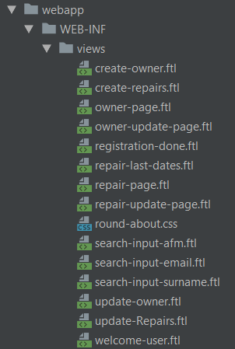

Figure 1 Intelij print screen regarding the FTL files used to our web application

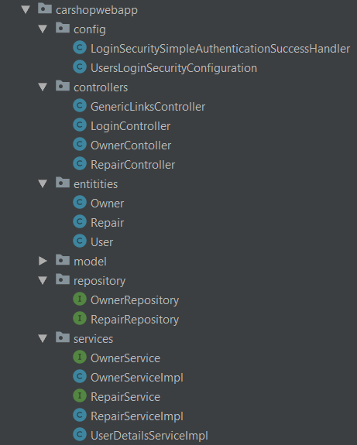

Figure 2 Intelij print screen of the main/java folder regarding the MVC structure used to our web application

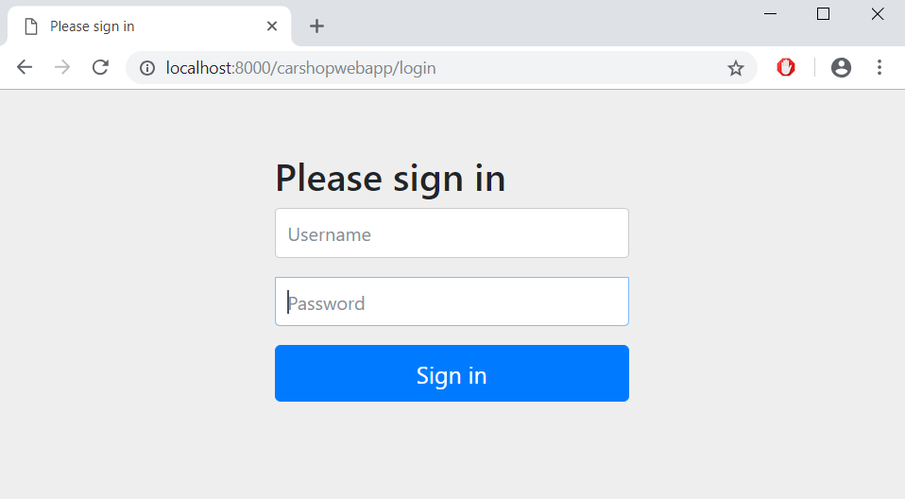

Figure 3 Login Form in order to access the site

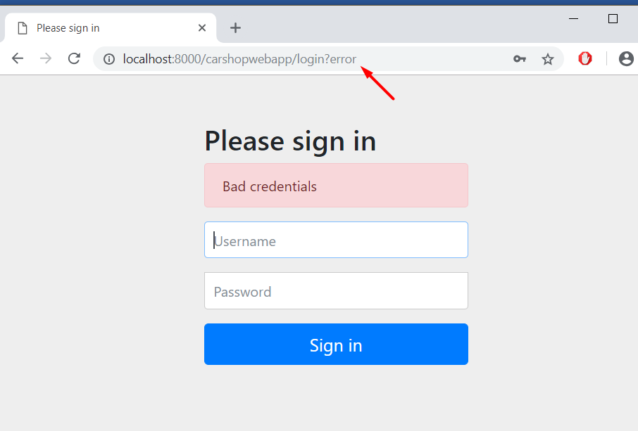

Figure 4 Login Form error message for unauthorized user information

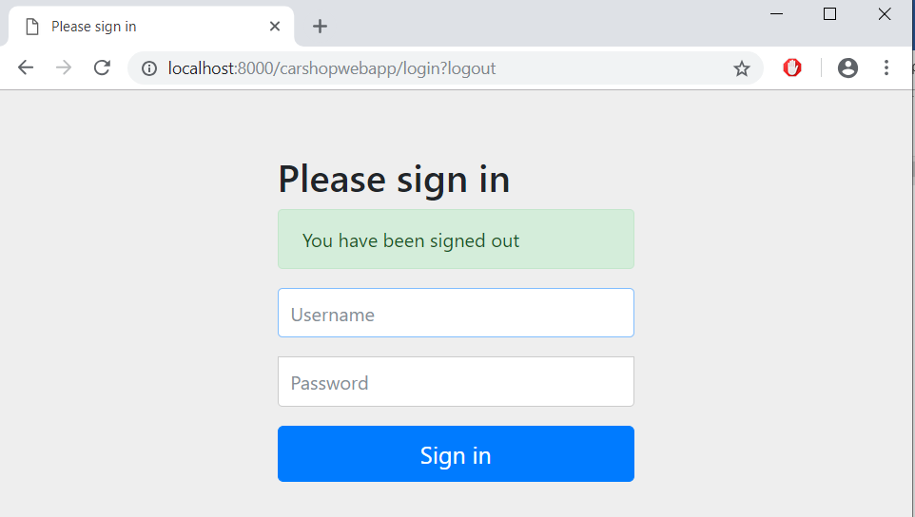

Figure 5 Logout page(delete the cookies of the user/admin sessions)

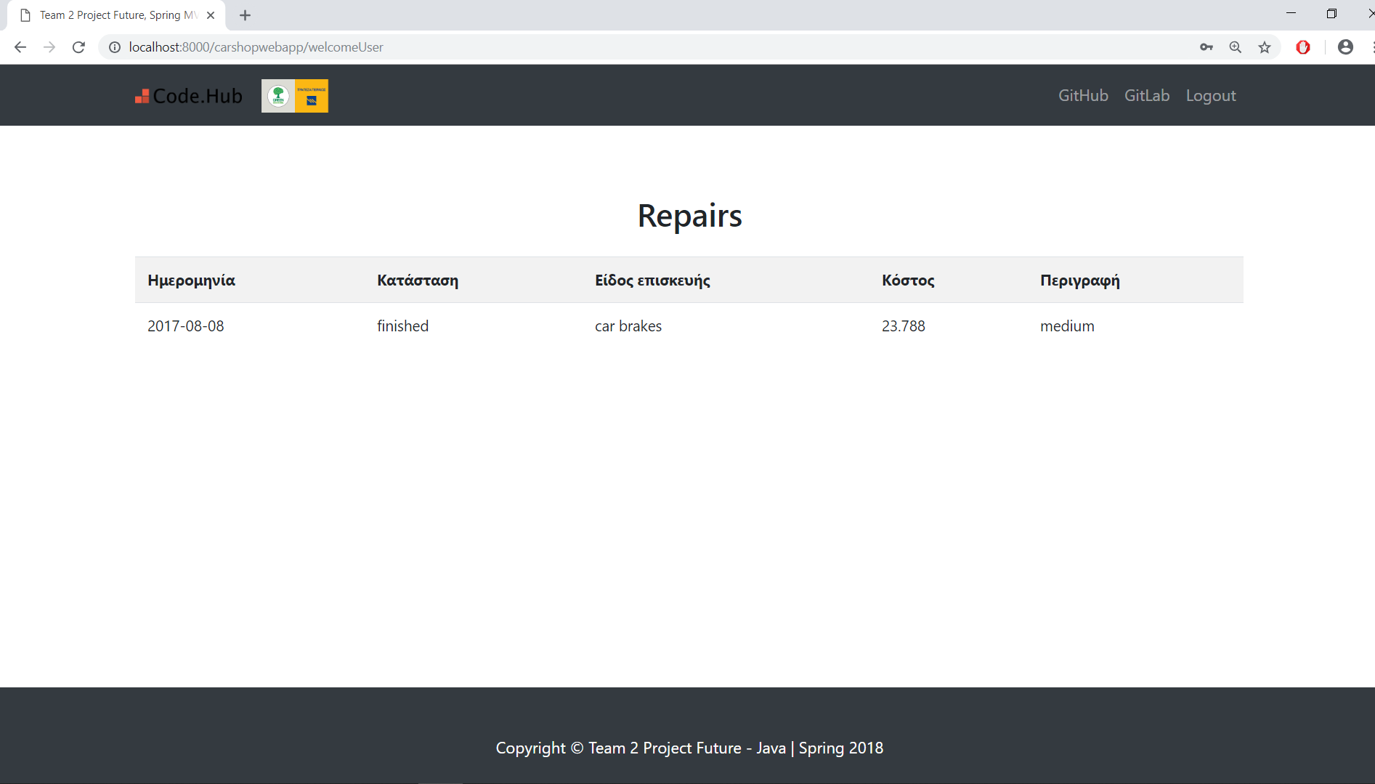

Figure 6 User login Redirect Page for e.g. (username , password) = (ssore1@gmpg.org , pass1234)

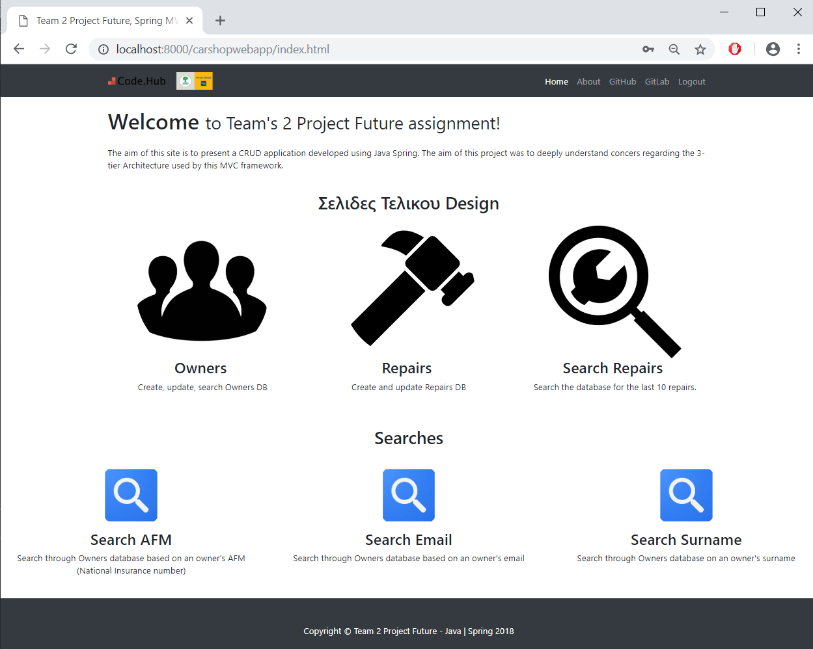

Figure 7 The main(index) page regarding the Admin web interface application. In order to login as an admin use the following credentials: (username , password) = (lrutgers3@ustream.tv, pass1234)

|  |  |  |
| --- | --- | --- |
|  |  |  |
|  |  |  |

Figure 8 The 3 Search pages : Afm, email, surname regarding the 5th record/user of our database

|  |  |  |
| --- | --- | --- |
|  |  |  |

Figure 9 The 3 Search pages Redirection site regarding the 5th record/user of our database where 3 different methods invoke upon the same result page (/search1, /search2, /search3)

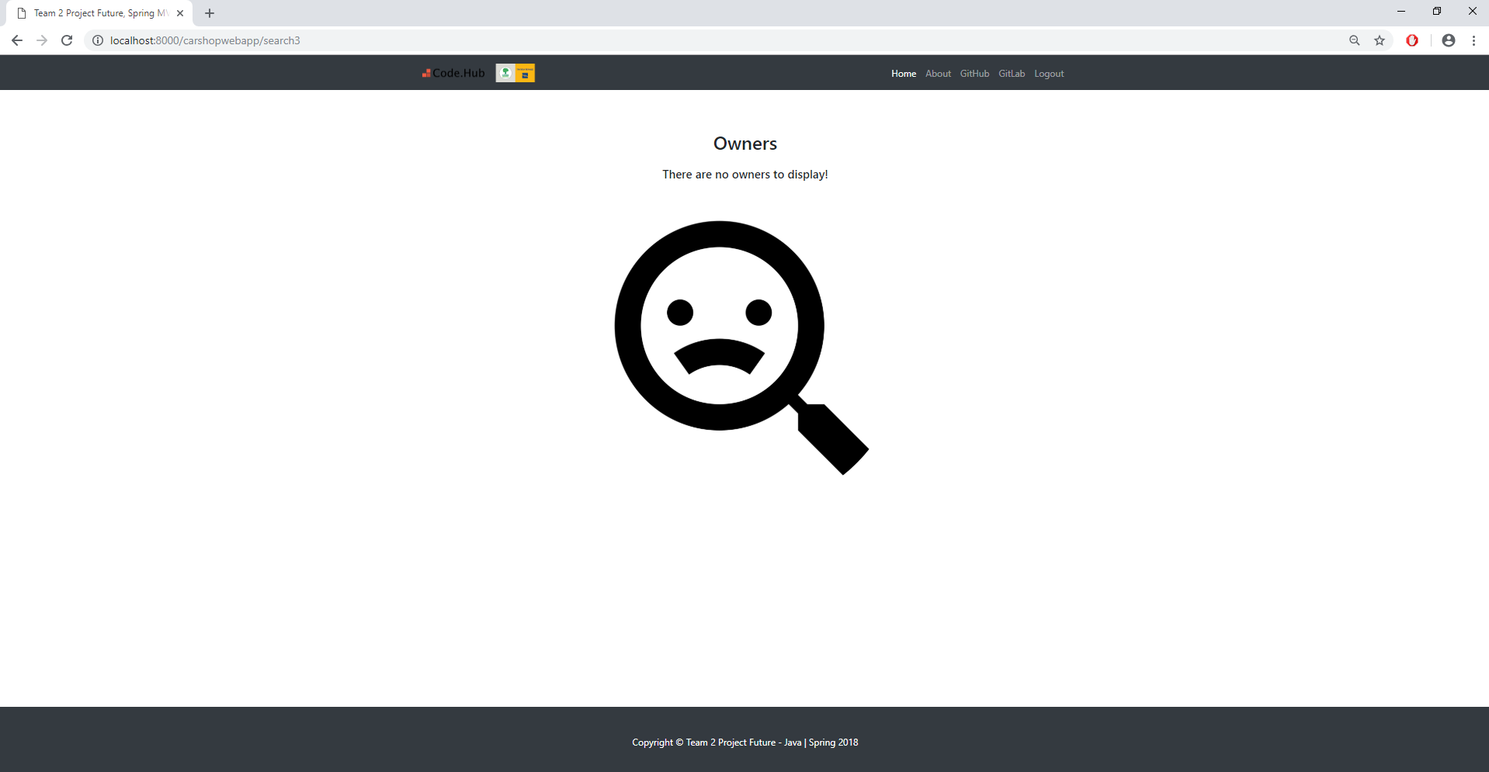

Figure 10 The 3 Search pages Redirection site regarding false input or generally no matched entry

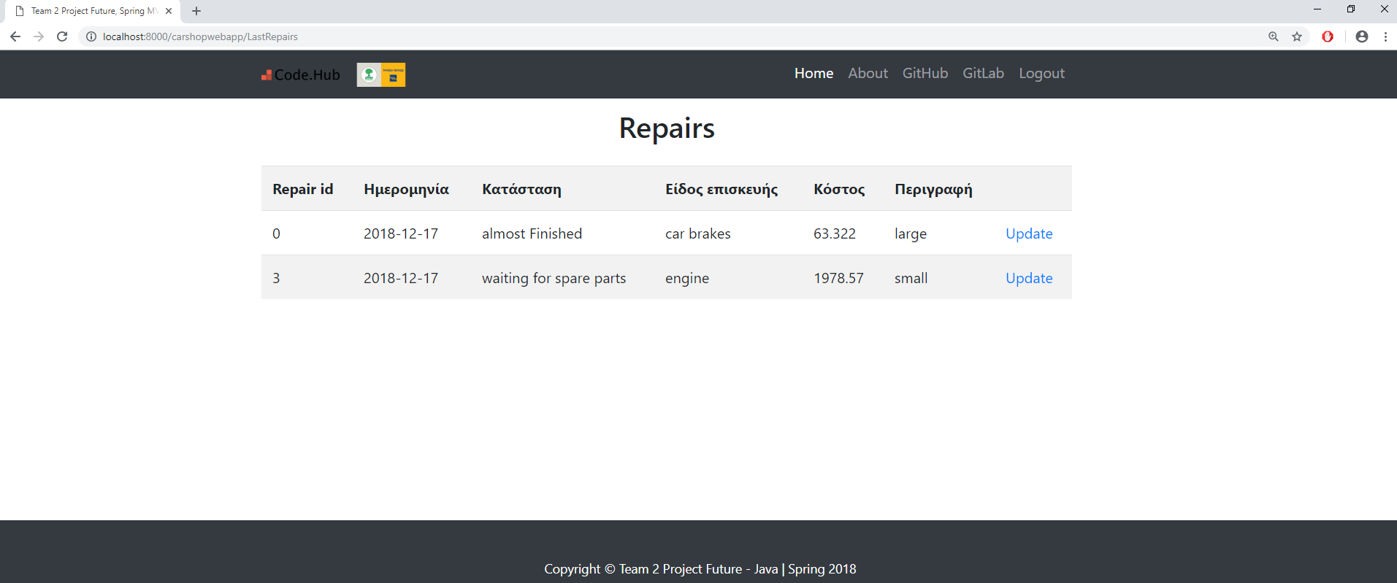

Figure 11 Search Repairs functionality regarding the database entries of 2018-12-17

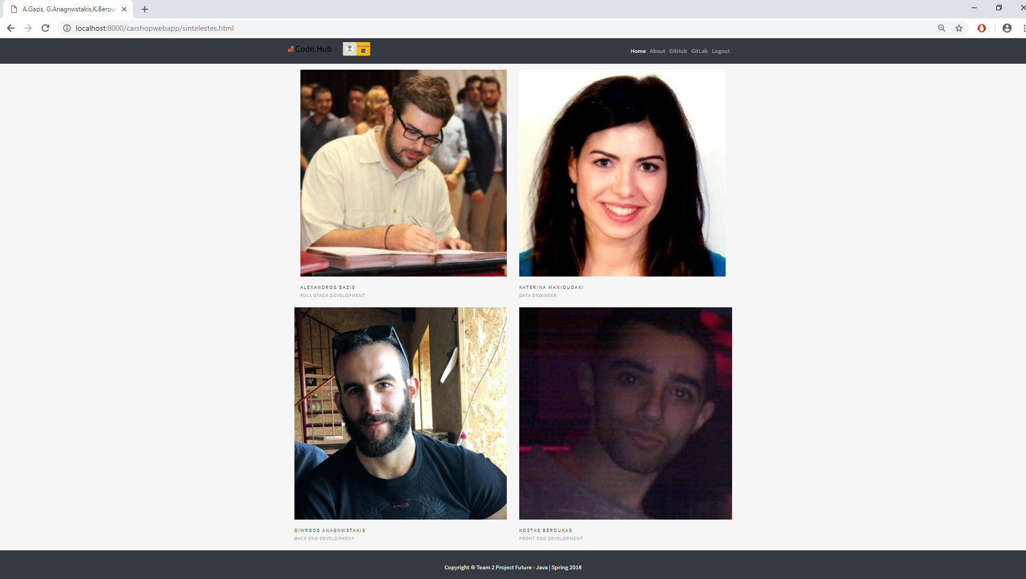

Figure 12 Contributors Page (About Option)

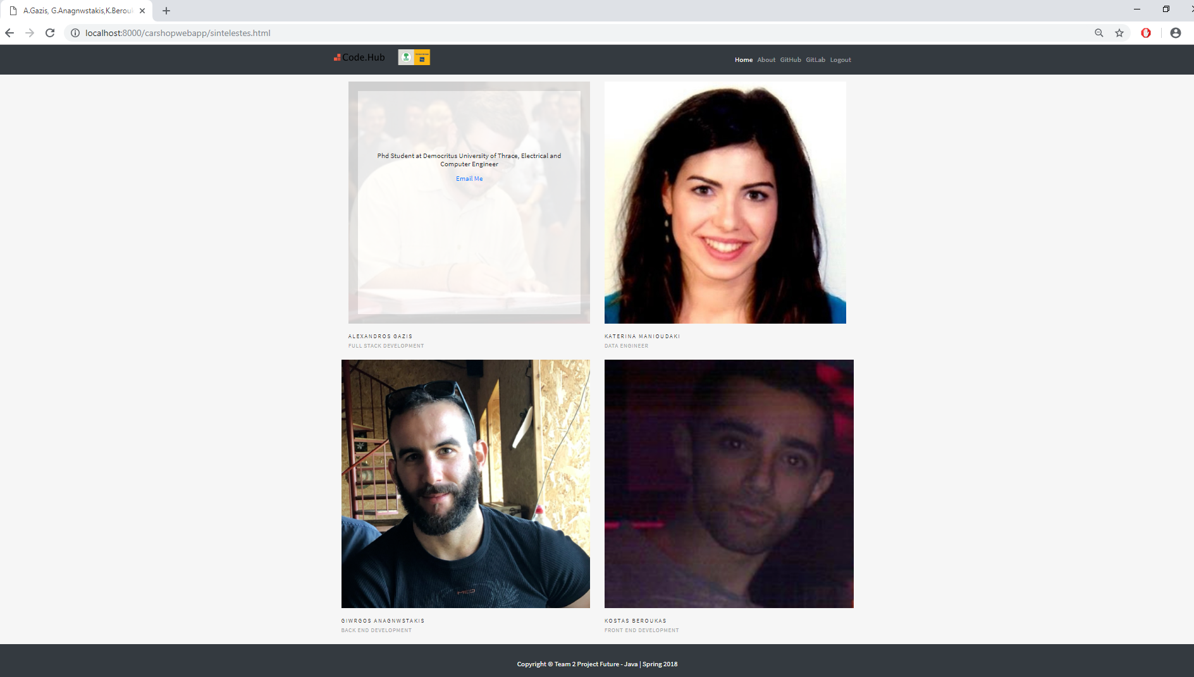

Figure 13 Contributors Page Functionality according to each image (onclick event)

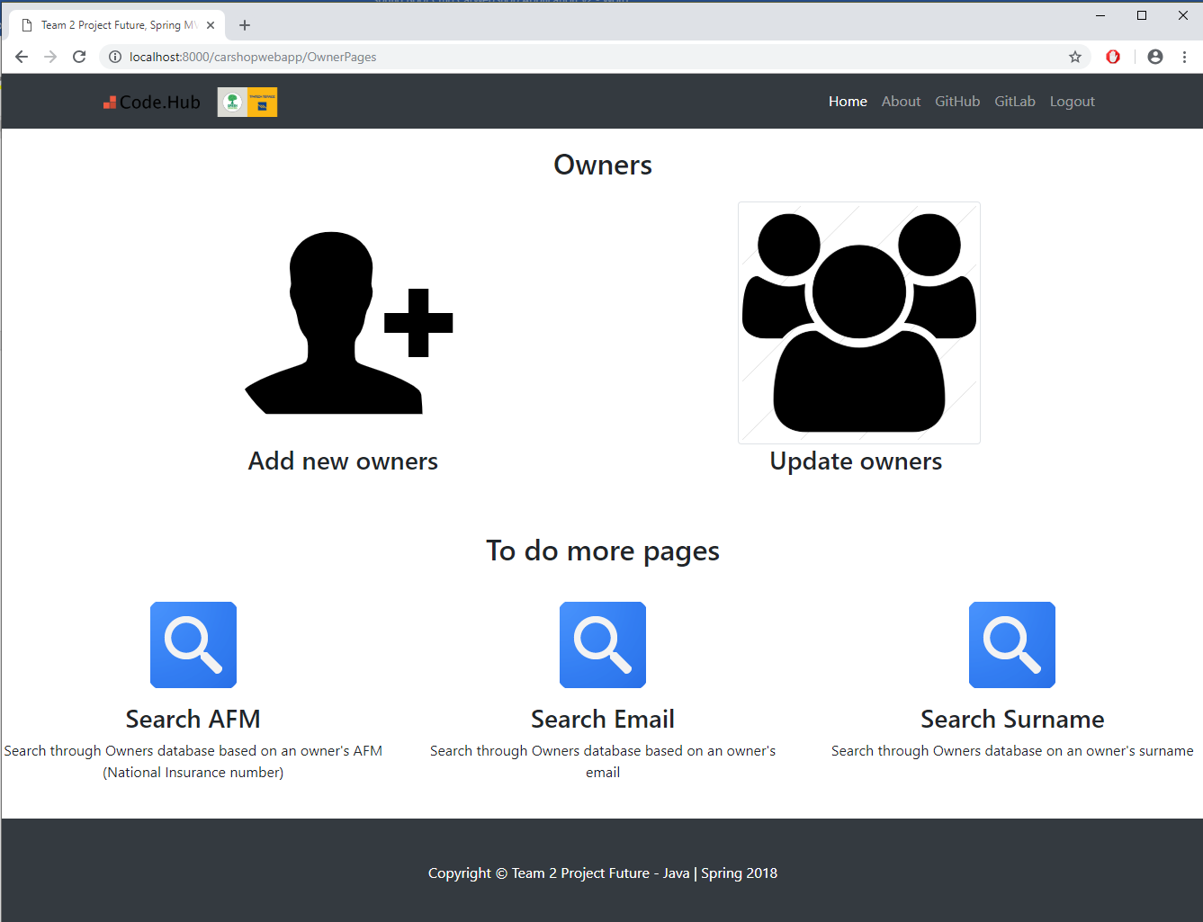

Figure 14 Owner Page of Admin’s web interface application

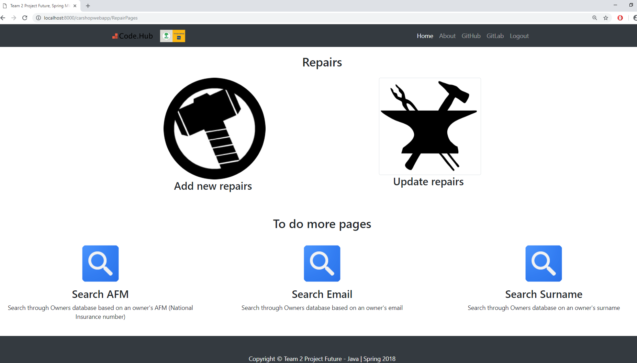

Figure 15 Repair Page of Admin’s web interface application

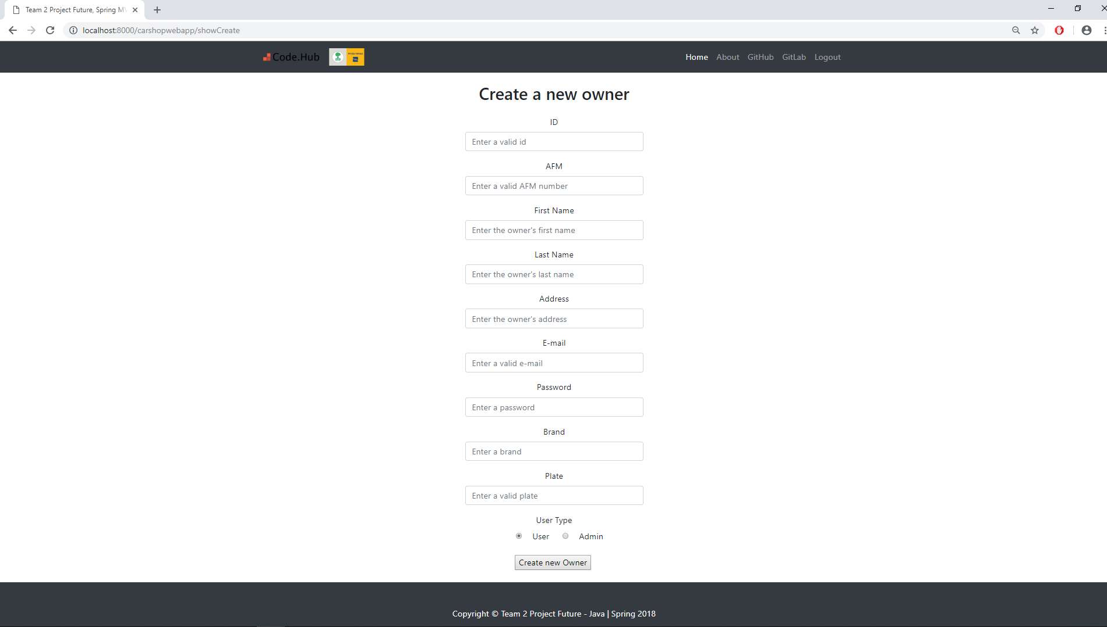

Figure 16 Create new entry for the Owner Page of Admin’s web interface application

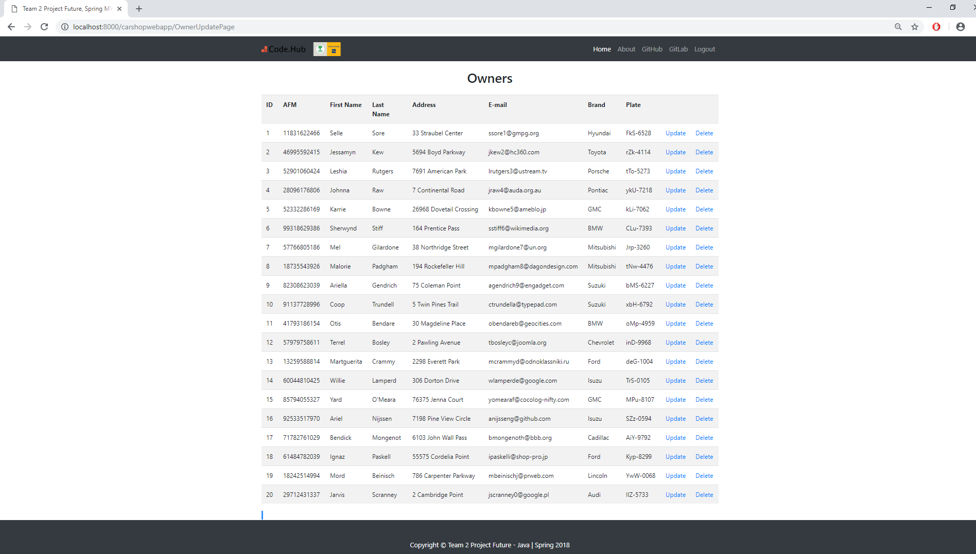

Figure 17 Display Owners page i.e. display all the values of the Owners table from the database

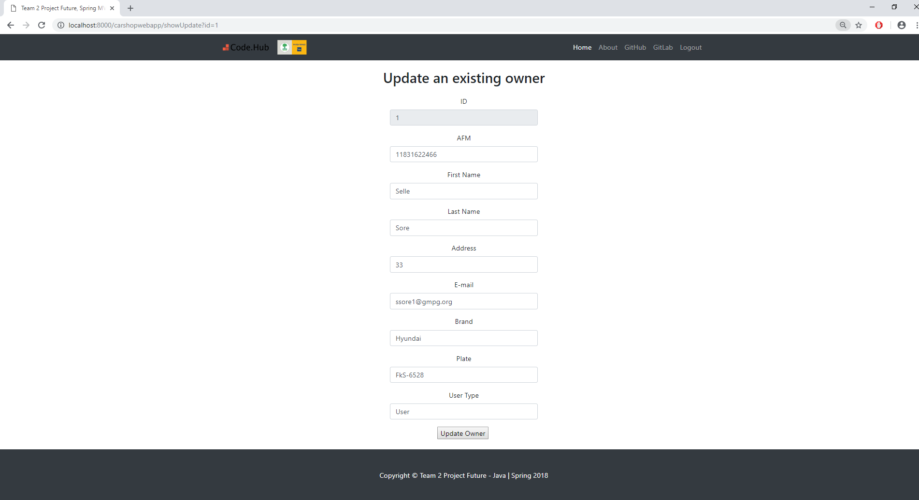

Figure 18 Owner’s Update option regarding the 1st entry ( the id is unable to be altered )

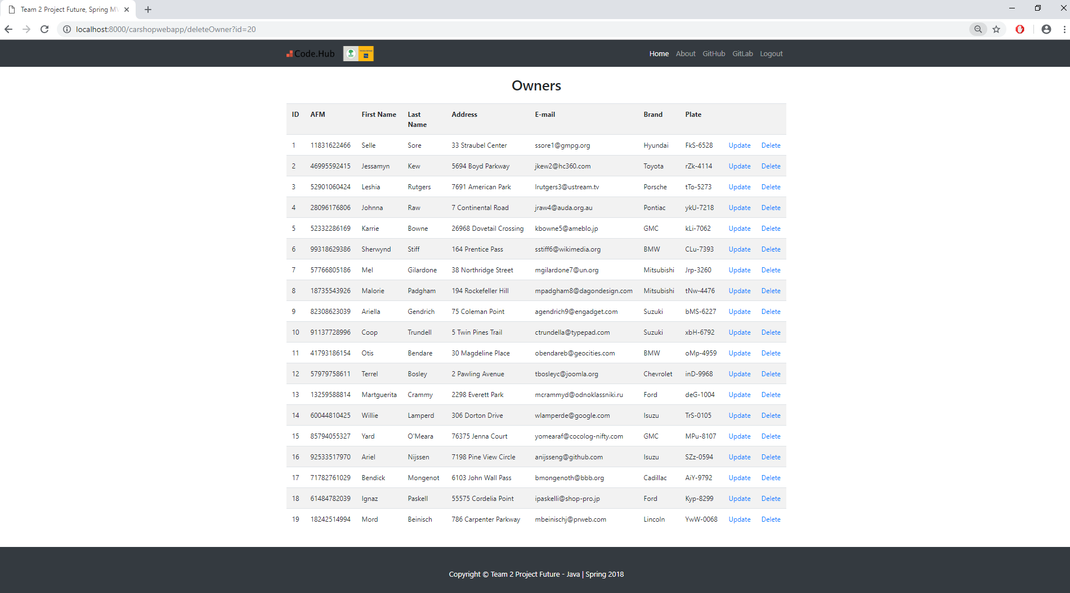

Figure 19 Owner’s Delete option functionality regarding the 20th entry

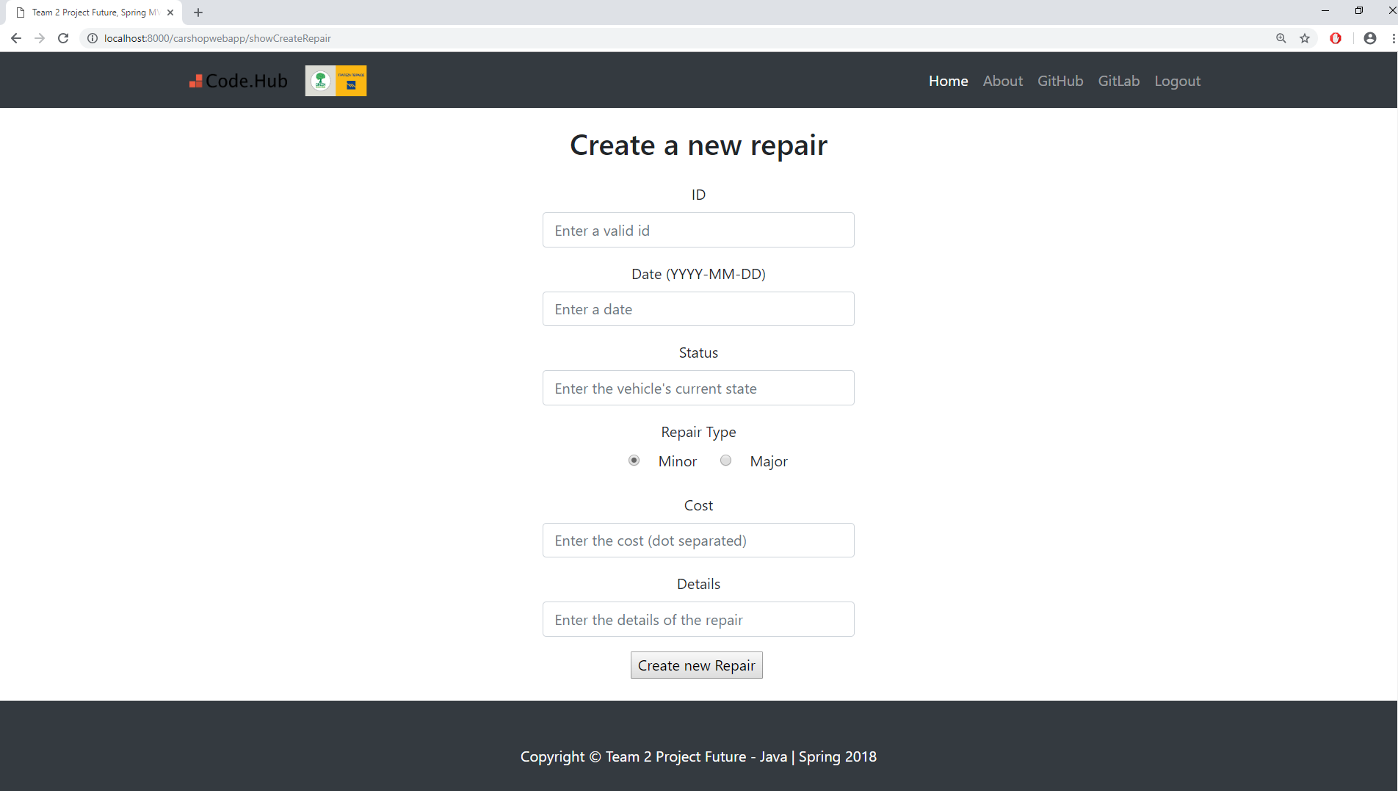

Figure 20 Create new entry for the Repair Page of Admin’s web interface application

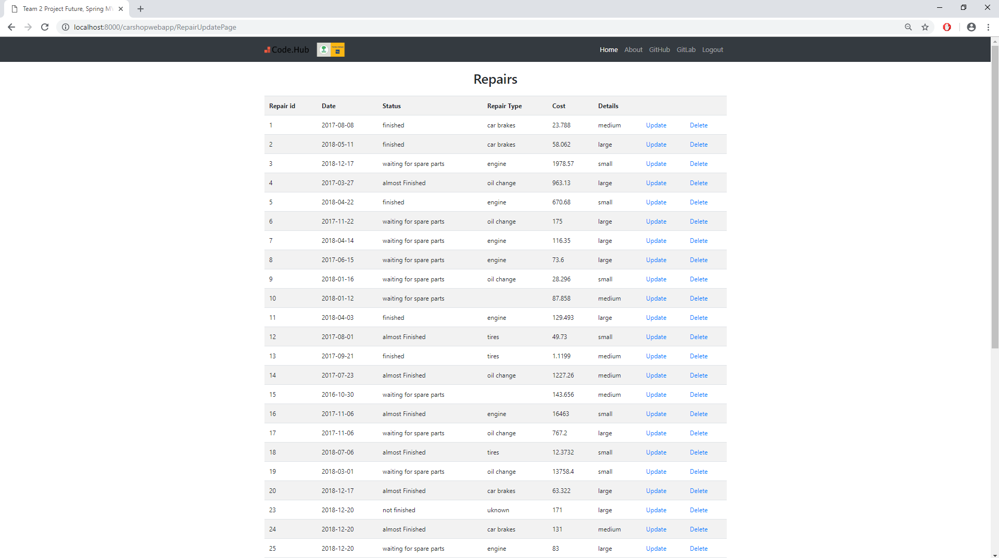

Figure 21 Display Repair page i.e. display all the values of the Repair’s table from the database (except for the password)

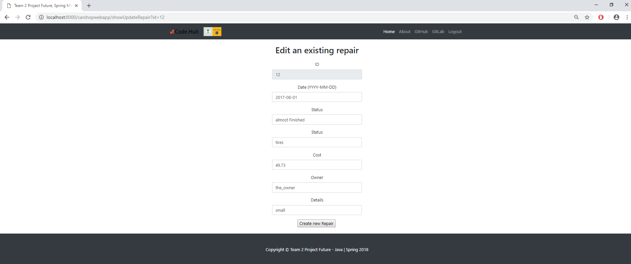

Figure 22 Repair’s Update option regarding the 12th entry ( the id is unable to be altered )

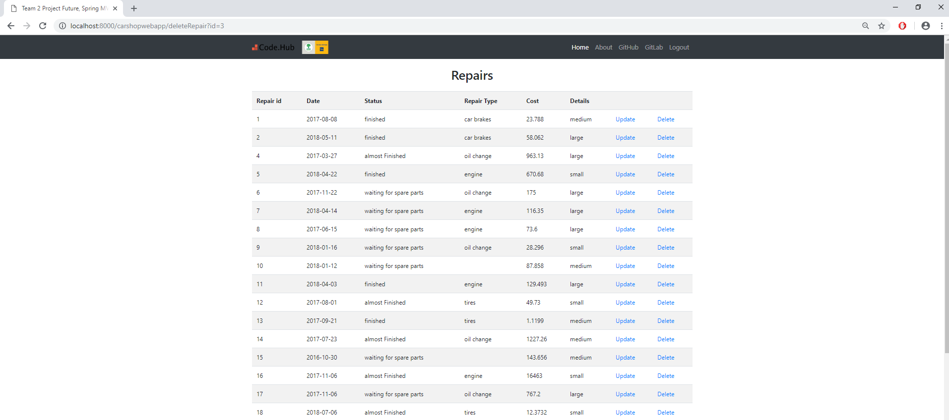

Figure 23 Repair’s Delete option functionality regarding the 3rd entry